**📤 AI Agent Assignment**

**🧾 SECTION 1: BASIC DETAILS**

**Name:** Saksham Gupta

**AI Agent Title / Use Case:** Spanish Vocabulary Learning Agent - An intelligent desktop application that adapts to user learning patterns and schedules Spanish vocabulary review sessions using spaced repetition and the Leitner system.

**🧠 SECTION 2: PROBLEM FRAMING**

* 1. **What problem does your AI Agent solve?**

Traditional vocabulary learning apps use rigid time-based schedules that don't adapt to individual learning patterns. Students often forget words they learned because reviews aren't timed optimally, and they waste time on words they've already mastered while struggling words get insufficient attention.

* 1. **Why is this agent useful?**

This agent delivers personalized learning by intelligently selecting which words to teach and when to review them based on individual performance. It uses session-based spaced repetition instead of fixed time intervals, ensuring optimal retention while minimizing study time through adaptive scheduling.

* 1. **Who is the target user?**

Spanish language learners who want systematic vocabulary building - including high school/college students preparing for exams, travelers planning trips to Spanish-speaking countries, and adult learners supplementing formal language courses with self-directed vocabulary practice.

* 1. **What *not* to include?**

Deliberately avoided grammar instruction, sentence construction, audio pronunciation, and social features (leaderboards, sharing) to maintain laser focus on vocabulary acquisition and retention. Also excluded web connectivity and cloud sync to keep the app simple.

**🧱 SECTION 3: 4-LAYER PROMPT DESIGN**

**🔹 3.1 INPUT UNDERSTANDING**

**Prompt:**

I need to create a vocabulary learning system that processes user performance data and vocabulary datasets using a publicly available dataset. How should I structure the input processing to capture learning state effectively?

**What is this prompt responsible for?**

This component processes and validates all incoming data - vocabulary datasets, user progress files, session counters, and real-time quiz responses to maintain accurate learning state. It suggested that the system should understand:

1. User's current vocabulary progress (mastery levels, attempt counts, correct answers)

2. Available vocabulary from CSV datasets with English-Spanish word pairs

3. Current session number and learning history

4. User's quiz responses and accuracy patterns

**🔹 3.2 STATE TRACKER**

**Prompt:**

Design a memory system for vocabulary learning that tracks:

- Individual word mastery levels (0-10 scale)

- Leitner box positions for spaced repetition (1-5 levels)

- Session-based scheduling instead of time-based

- Performance analytics (attempts, correct answers, accuracy trends)

How should I implement persistent memory that evolves with user performance?

**How does this help the agent "remember"?**

The agent maintains comprehensive learning state through JSON persistence, tracking each word's journey through the Leitner system. Variables store session progress, while file-based memory ensures continuity across app restarts, enabling intelligent long-term learning adaptation.

**🔹 3.3 TASK PLANNER**

**Prompt:**

Create a multi-step decision tree for vocabulary learning sessions:

1. Analyze current learning state and due words

2. Decide between learning session vs revision session

3. Select optimal word mix (new words + strategic reviews)

4. Plan session flow (flashcards for new words, direct quizzes for reviews)

5. Update learning model based on performance

How do I implement this logic that adapts to user needs?

**What steps does your agent take internally to solve the problem?**

The agent uses conditional branching: analyzes due words → determines session type → selects word distribution (3 new, 4 low-mastery, 2 medium, 1 high) → presents appropriate interface (flashcard vs direct quiz) → updates Leitner boxes based on performance. Complexity is managed through modular functions and clear state transitions.

**🔹 3.4 OUTPUT GENERATOR**

**Prompt:**

Design user interfaces and feedback systems for vocabulary learning:

- Clean GUI with progress indicators and visual feedback

- Color-coded quiz results (green=correct, red=wrong)

- Comprehensive session summaries with performance analytics

Can you create me such an UI?

**What kind of output formatting or phrasing did you aim for?**

Focused on clean, encouraging interfaces with visual hierarchy - large fonts for vocabulary words, color-coded feedback for immediate reinforcement, and detailed but digestible progress summaries. Used Spanish phrases ("¡Correcto!", "¡Excelente!") to reinforce language immersion and maintain motivational tone throughout.

**🔍 SECTION 4: CHATGPT EXPLORATION LOG**

|  |  |  |  |  |
| --- | --- | --- | --- | --- |
| Attempt | Prompt Variant | What Happened | What You Changed | Why You Changed It |
| 1 | "Create a vocabulary learning app to show translations and then ask quiz" | Generated basic flashcard system and quiz system with no intelligence | Added flashcards and quiz for practice | Needed adaptive learning, not just drilling |
| 2 | "Build vocabulary app with spaced repetition using time intervals" | Used day-based scheduling which was impractical for testing | Changed to session-based intervals | Time-based system hard to test and didn't fit usage patterns |
| 3 | "Fix the GUI to show both learning and review phases separately" | Mixed new and review words randomly | Separated into distinct phases with different flows | Users need different approaches for new vs familiar words |
| 4 | "Make the AI decide when to show revision sessions" | Always showed revision option | Added intelligence to only show when ≥5 words due | Avoid overwhelming users with unnecessary options |
| 5 | "Improve word selection algorithm : Give new words every session but also prioritize the review words with low mastery” | Selected words randomly within categories | Implemented weighted selection prioritizing struggling words | Need to focus on words that need attention most |

**🧪 SECTION 5: OUTPUT TESTS**

**Test 1: Normal Learning Session**

Input: First-time user with fresh vocabulary dataset

Output:

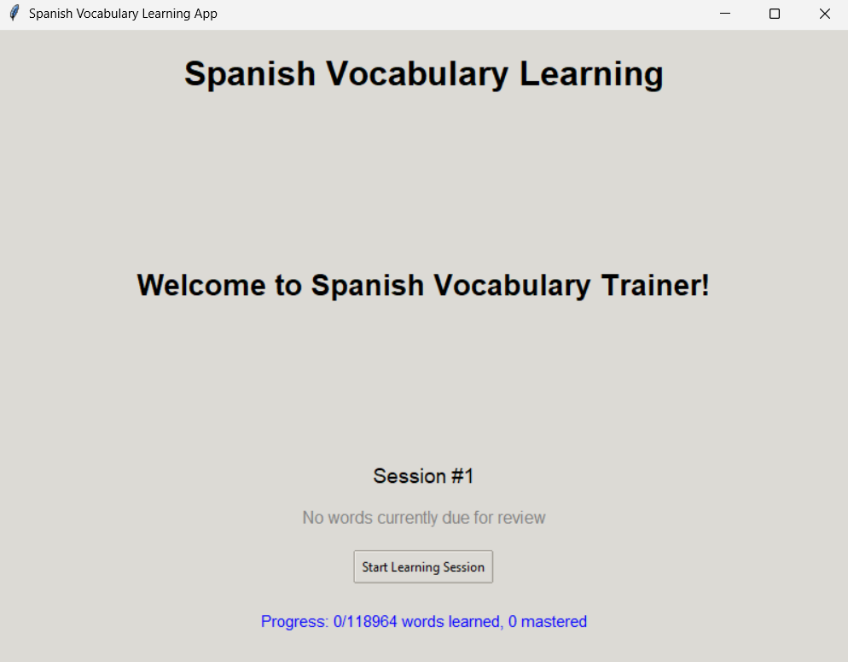

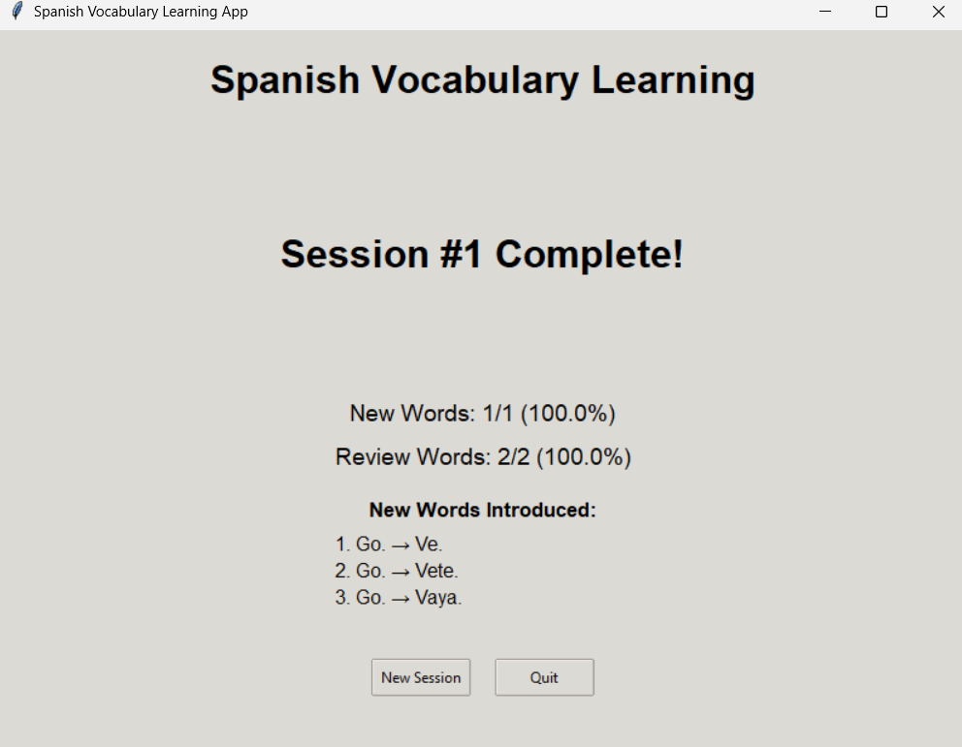

**Test 2: Revision Session Trigger**

Input: User with 20 words due for review after completing 18 sessions  
Output:

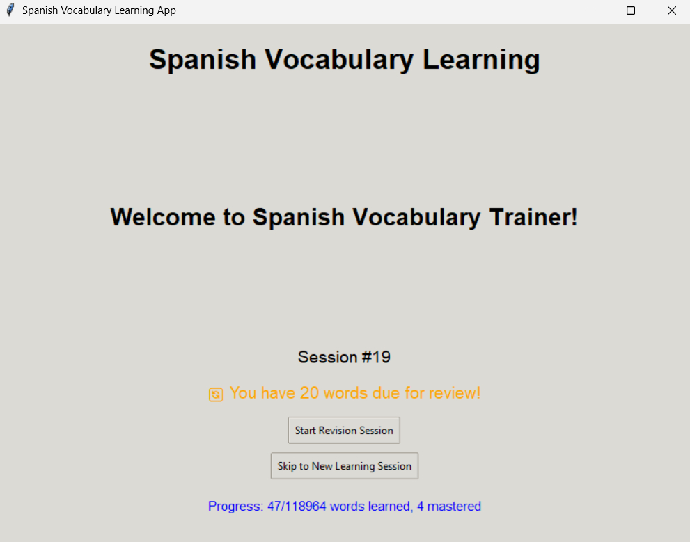**Test 3: Edge Case - No Available Words**

Input: User has learned all vocabulary, no words due for review  
Output:

No words available for learning or review.

Progress: 500/500 words learned, 487 mastered

[Quit]

**🔄 SECTION 6: REFLECTION**

**6.1. What was the hardest part of this assignment?**

The most challenging aspect was designing the intelligent decision-making system that balances new word introduction with strategic review scheduling. Getting the Leitner box progression logic right took multiple iterations, especially ensuring that words move appropriately between boxes based on performance while preventing the system from becoming too easy or too difficult.

**6.2. What part did you enjoy the most?**

I most enjoyed implementing the adaptive word selection algorithm that creates personalized learning sessions. Seeing the AI automatically adjust the difficulty mix based on user performance felt like creating genuine intelligence. The visual feedback system with color-coded results was also satisfying to implement and test.

**6.3. If given more time, what would you improve or add?**

I would add audio pronunciation using text-to-speech, implement learning analytics with visual progress charts, and create themed vocabulary categories (food, travel, business). A sentence practice mode using learned vocabulary in context would also significantly enhance retention and practical application.

**6.4. What did you learn about ChatGPT or prompt design?**

I learned that specificity in prompts is crucial - vague requests like "make it better" yielded generic responses, while detailed technical requirements produced actionable solutions. Breaking complex problems into smaller, focused prompts worked better than trying to solve everything at once. The iterative refinement process was essential for achieving the desired functionality.

**6.5. Did you ever feel stuck? How did you handle it?**

I got stuck on the session-based timing system, initially trying to adapt time-based algorithms. I handled it by stepping back and reconsidering the core requirements - users want predictable, session-based learning rather than calendar-dependent schedules. This insight led to the breakthrough of using session counters instead of timestamps.

**🧠 SECTION 7: HACK VALUE**

**Did you go beyond the brief in any way?**

Yes, I implemented several advanced features beyond basic vocabulary learning:

* **Intelligent Session Management**: The AI automatically determines optimal session types and word distributions rather than following fixed patterns
* **Sophisticated Progress Tracking**: Implemented a dual-system approach with both mastery levels (0-10) and Leitner boxes (1-5) for nuanced progress representation
* **Adaptive User Interface**: Different interaction flows for new words (flashcard + quiz) vs review words (direct quiz) based on learning state
* **Session-Based Innovation**: Created a novel session-counter approach instead of traditional time-based spaced repetition, making the system more practical for actual usage patterns

The system simulates genuine AI tutoring by continuously adapting to user performance and making pedagogically sound decisions about what to teach and when to review.